Infinitive Phrase as Head

🟩 What is Prepositional Phrase (PP) as Head?
# Source: AI Source: Provided by: [Data Path: Persons Table -> ID Column: 1, Name_En Column: Motasem Essam] -> From: [Chatgpt (GPT‑5 Mini)] on [8/7/2025]
An Infinitive Phrase is a phrase built around an infinitive verb—that is, the base form of a verb usually preceded by “to”. In an infinitive phrase, the head is the infinitive verb itself.

🔹 Structure of an Infinitive Phrase
# Source: AI Source: Provided by: [Data Path: Persons Table -> ID Column: 1, Name_En Column: Motasem Essam] -> From: [Chatgpt (GPT‑5 Mini)] on [8/7/2025]
[to + verb] + (optional modifiers, objects, or complements)

Example:
- to win the game → "to win" is the head, and "the game" is its object.

🔹 Role of the Infinitive Head
# Source: AI Source: Provided by: [Data Path: Persons Table -> ID Column: 1, Name_En Column: Motasem Essam] -> From: [Chatgpt (GPT‑5 Mini)] on [8/7/2025]
The head infinitive verb determines the function of the phrase, which can act as:
- Noun (subject, object, complement)
- Adjective
- Adverb

🔹 Examples by Function
# Source: AI Source: Provided by: [Data Path: Persons Table -> ID Column: 1, Name_En Column: Motasem Essam] -> From: [Chatgpt (GPT‑5 Mini)] on [8/7/2025]
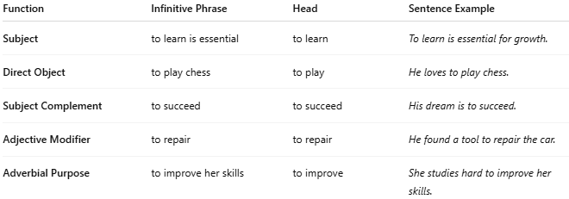
Function | Infinitive Phrase | Head | Sentence Example
Subject | to learn is essential | to learn | To learn is essential for growth.
Direct Object | to play chess | to play | He loves to play chess.
Subject Complement | to succeed | to succeed | His dream is to succeed.
Adjective Modifier | to repair | to repair | He found a tool to repair the car.
Adverbial Purpose | to improve her skills | to improve | She studies hard to improve her skills.

✅ Key Notes:
# Source: AI Source: Provided by: [Data Path: Persons Table -> ID Column: 1, Name_En Column: Motasem Essam] -> From: [Chatgpt (GPT‑5 Mini)] on [8/7/2025]
- The head of an infinitive phrase is always the infinitive verb.
- The phrase as a whole takes on different syntactic roles depending on context.
- Infinitive phrases can include objects, modifiers, and complements.

